Student’s name | …………………………………………………….…… | Grade | 3
Subject | Computer | Week No. | 3
Lesson Title | Inside a Computer | Unit
Worksheet No. ( 3 ) (Answer)

write the correct name of each part.
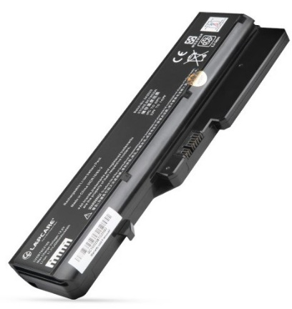
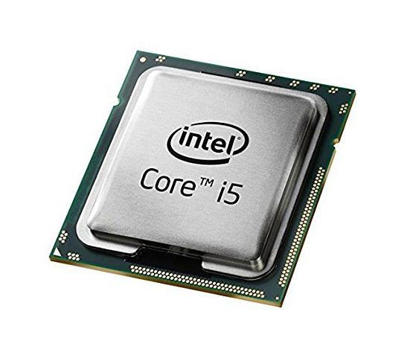
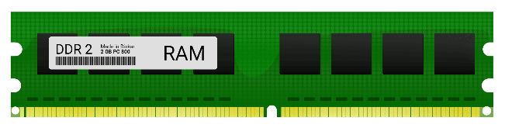
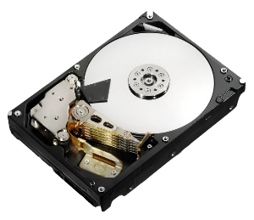
Battery Laptop
CUP
RAM
Hard Disk
Battery Laptop
Hard Disk
RAM
Good Luck

CPU

